Attendes app:

0-The senareo

A doctor required to produce the process of setting up students smoother, and he came up with the concept of using a QR reader, which is a reader whose picture is placed on the door and scanned by the phone camera, and then your attendance is automatically recorded at the doctor.

1-Requirement

Clint for the Dr:

-sign in

-upload the Qr to the server

-see who attend who is not

Clint for the students :

-sign in

-take a scan of the Qr

Server :

-check for the sign in for Dr and Stu

-update the Qr

-if it take scan from any student or not sent data to the Dr

-the scan should be in specific time

2- The Degrame

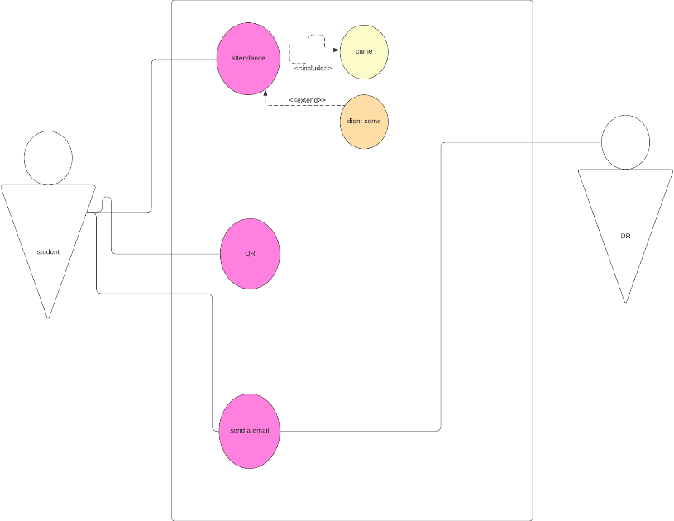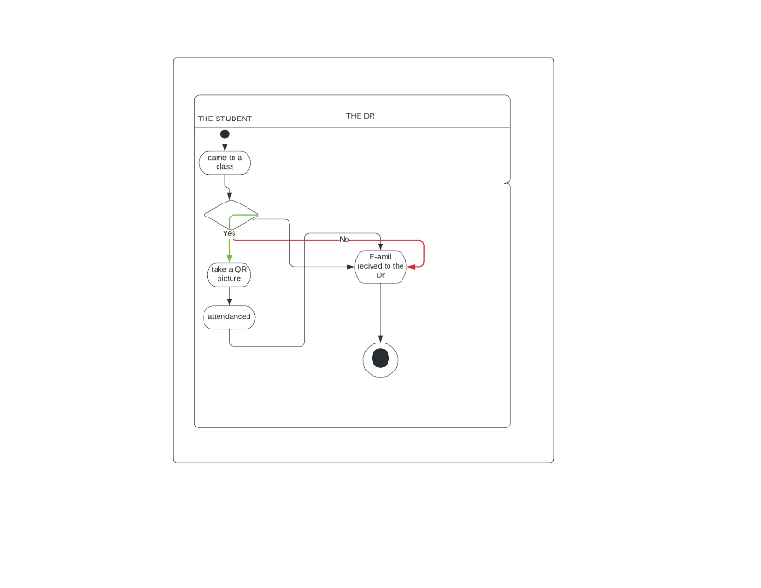

3-Input

3/1-For Code

On GitHub flowing this link:

<https://github.com/mu-se373-190706822/final-project>

3/2-for API package

dependencies:

  flutter:

    sdk: flutter

  qr_flutter: ^4.0.0

  barcode_widget: ^2.0.1

  # The following adds the Cupertino Icons font to your application.

  # Use with the CupertinoIcons class for iOS style icons.

  cupertino_icons: ^1.0.2

  image_gallery_saver: '^1.7.1'

  flutter_barcode_scanner: ^2.0.0

  share: ^2.0.4

  screenshot: ^1.2.3

dev_dependencies:

  flutter_test:

    sdk: flutter

  # The "flutter_lints" package below contains a set of recommended lints to

  # encourage good coding practices. The lint set provided by the package is

  # activated in the `analysis_options.yaml` file located at the root of your

  # package. See that file for information about deactivating specific lint

  # rules and activating additional ones.

  flutter_lints: ^1.0.0

4-out put

4/1-for UI :

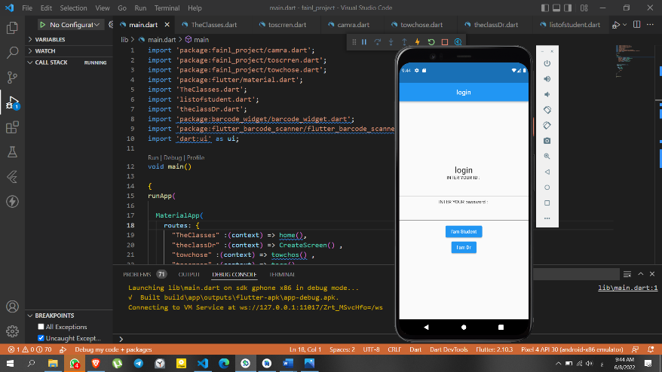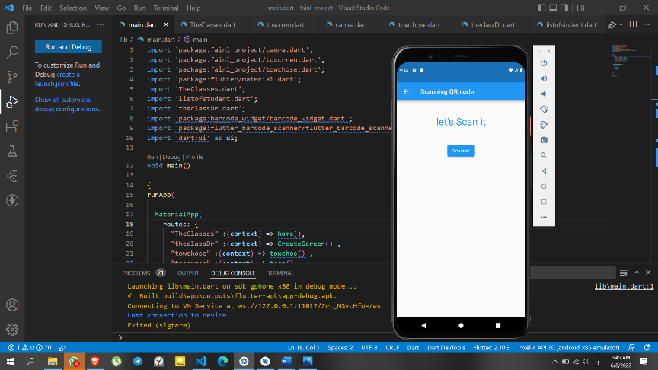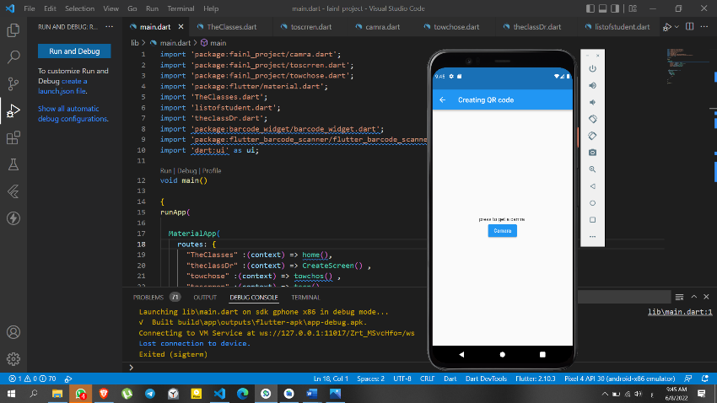

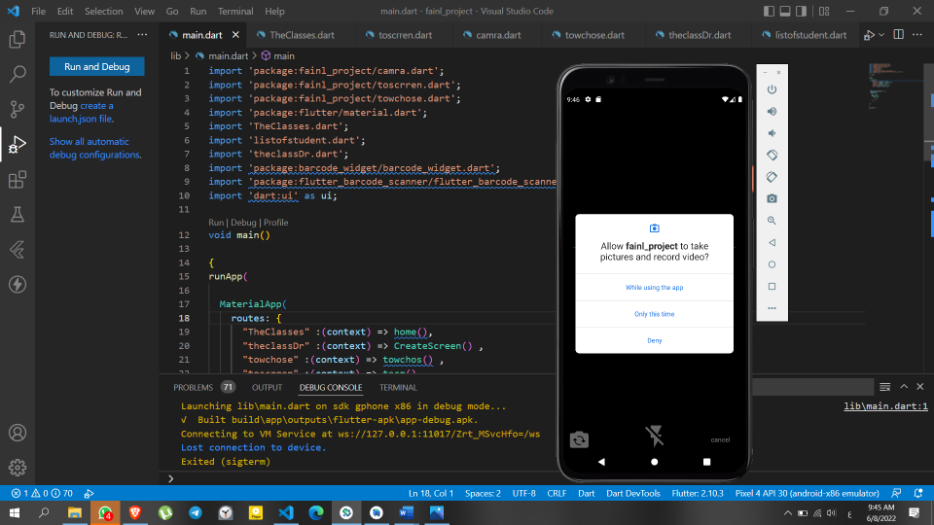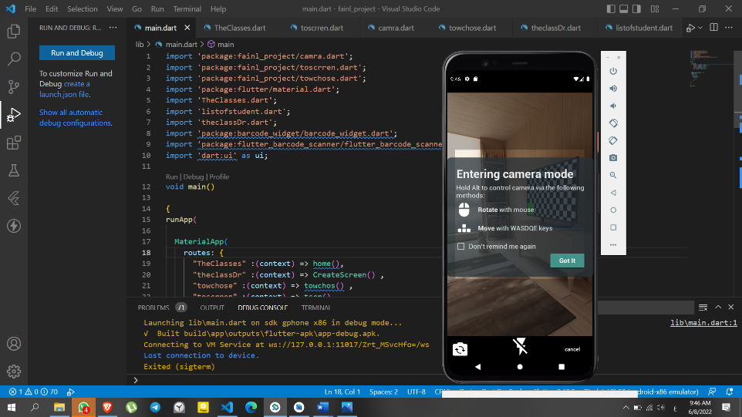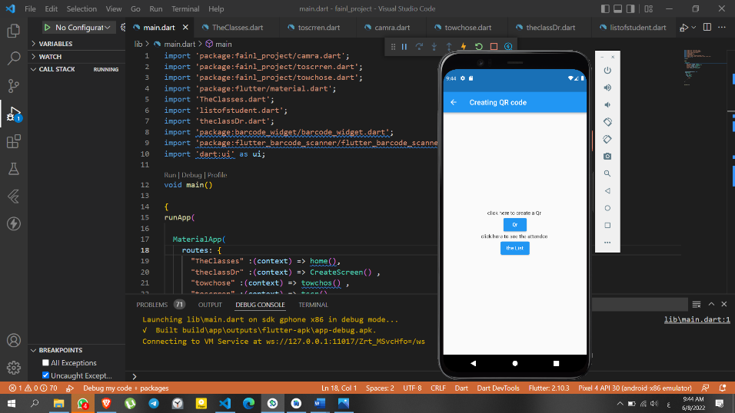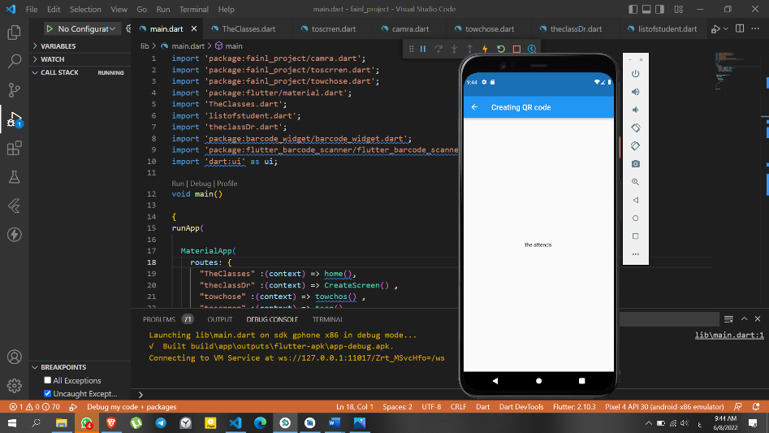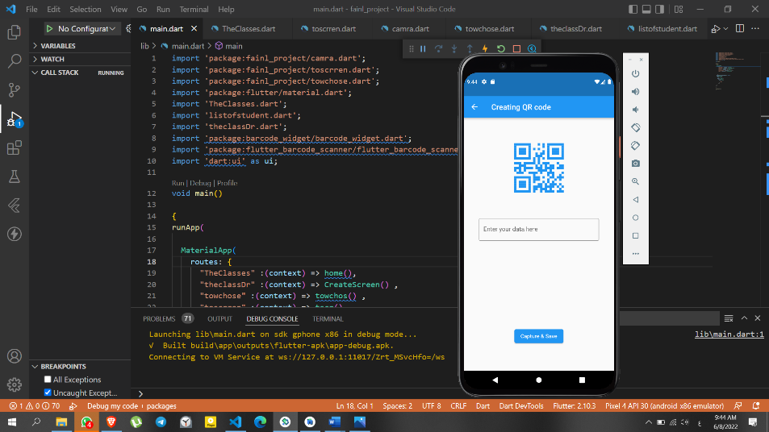

4/2-For Database*1 :

The table of the database I used firbase

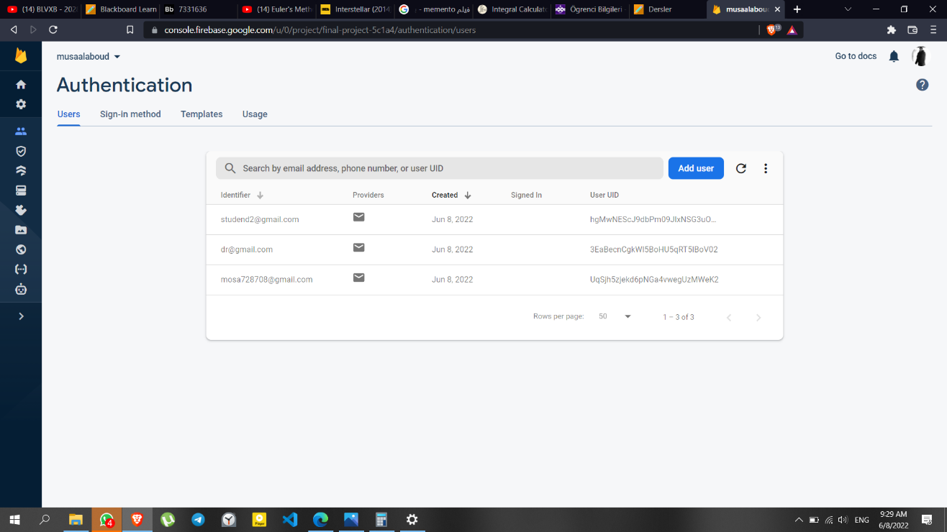

Link:

<https://console.firebase.google.com/u/0/project/final-project-5c1a4/authentication/users>

--------

1*Nots:

The app is not connect with the firbase because there is a lot of updata and new version of flutter I used version2 and I could not connect them .